MSE policy model
D3.8

31 October 2026 | Version 0
Rik Kreeftenberg, Jeroen Steenbeek, Villy Christensen (EII)
Public

Document information

Grant Agreement | 101157456
Project Acronym | SURIMI
Project Title | Integration of innovative and reliable socio-ecological models and user-driven solutions into the Digital Twin Ocean, to facilitate what-if scenarios and decision support, under a co-creation approach.
Deliverable Number | D3.8
Work Package Number | WP3
Deliverable Title | MSE policy model
Lead Partner | UOXF
Author(s) | Rik Kreeftenberg, Jeroen Steenbeek, Villy Christensen (EII)
Due Date | 31 October 2026
Submission Date
Dissemination Level | Public
Type of Deliverable | Other

Version | Summary of Changes
Version 0 | Initial version

SUMMARY
Entry | Detail
Programming language | C# .Net
Nr of kubernetes pods | 1
Github repo | https://github.com/SURIMI-project/SURIMI-fisheries-authority
Licence | EUPL-1.2

CONTENTS
Document information 1
SUMMARY 2
1. Model purpose 4
2. Process overview and scheduling diagrams 4
3. Configuration 5
3.1 Recruitment 5
3.2 QuotaShare 7
3.3 Initial Quota 8
4. Inputs 8
4.1 InitialiseSimulation 8
4.2 CreateRegulations 8
4.3 UpdateBiomass 9
4.4 Update CatchDisposition (total) 9
5. Outputs 10
5.1 GetRegulations 10
5.1.1 Assessment 10
5.1.2 Update Quotas and First year 10
5.1.3 Shared EwE calculation library 11

1. Model purpose
Management Strategy Evaluation (MSE) is a simulation-based approach used in fisheries management to test and compare alternative management strategies under uncertainty. In SURIMI it runs many simulations with varying assumptions about stock biomass, recruitment, catches, quotas, observation errors, and environmental conditions to evaluate which strategies are most likely to achieve objectives such as sustainable harvests and stock conservation.
The MSE Policy model is implemented by the Fisheries Authority service that is a component of the SURIMI simulation framework. SURIMI is a multi-model system that simulates marine fisheries ecosystems. All models — including this one — communicate exclusively with the SURIMI Controller over gRPC, using a shared Protobuf-based protocol (BSR.Surimi.Surimi-Protocol).
The Fisheries Authority model represents the regulatory authority in the simulation. It provides fishing regulations (Total Allowable Catches) to other models and receives updates on biomass and catch dispositions from the Controller, which aggregates data from the ecology and fleet models.

2. Process overview and scheduling diagrams
The Fisheries Authority service in the SURIMI model ensemble is shown in the context diagram below. It shows the data flows within the system and the place of the MSE Policy model among the other models.
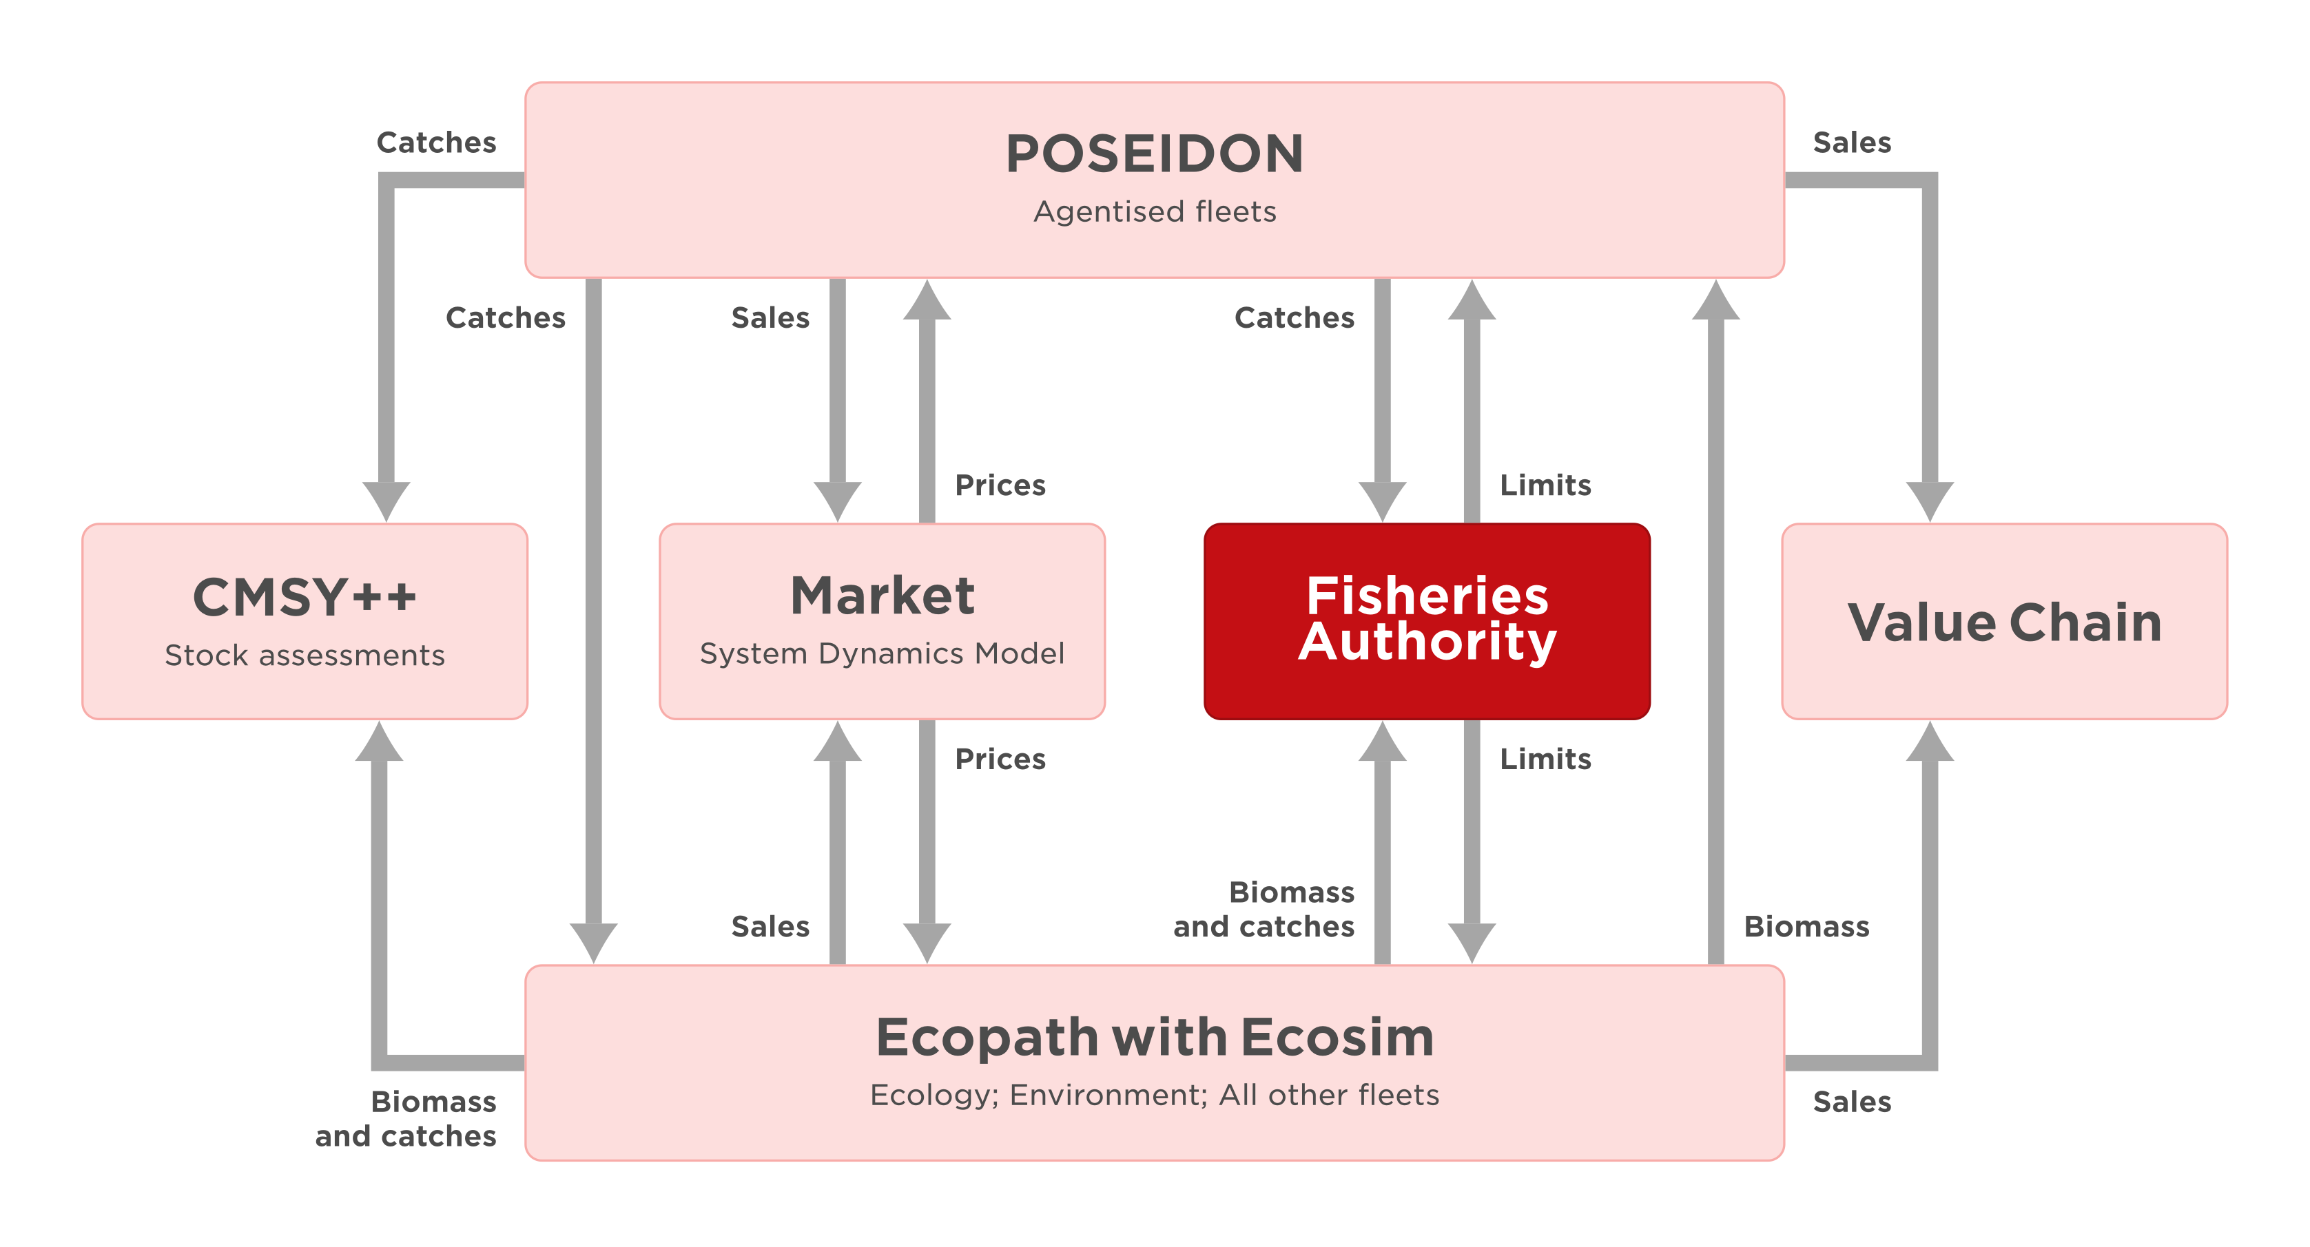
Figure 1. The position of the Fisheries Authority in the SURIMI context
The sequence diagram below focusses on the communication with the Fisheries Authority service. It only communicates with the Controller.
An MSE experiment runs multiple simulations in parallel, with stochastic variation in stock assessment and quota calculation, to explore the range of possible management outcomes. At the end of the experiment, the mean, P05 and P95 are calculated and stored as output of the experiment.
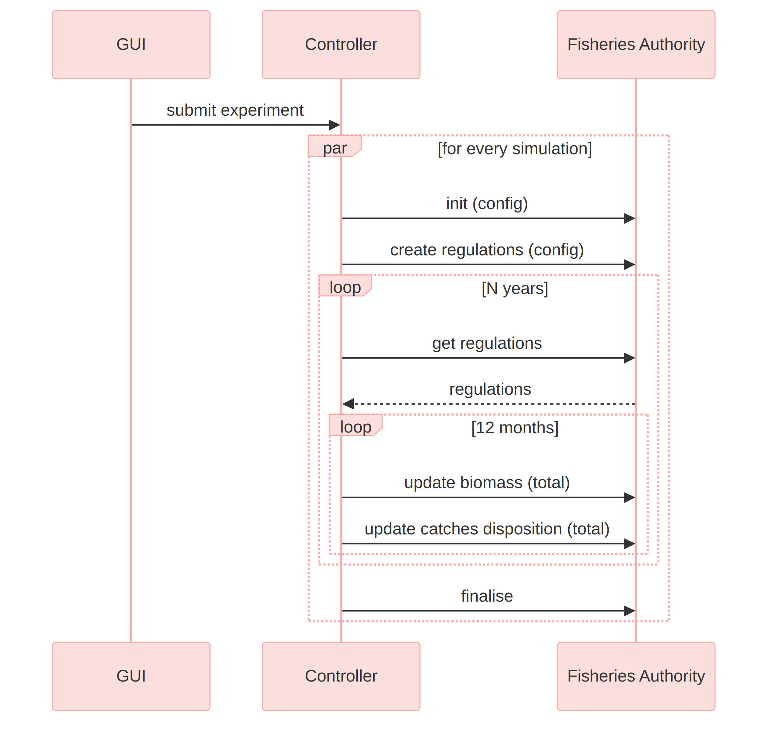
Figure 2. The SURIMI sequence diagram and the communication with the Fisheries Authority

3. Configuration
The Fisheries Authority service needs to be configured to be able to do its calculations. The configuration depends on the scenario (northwestern_med, anchovy_bay or aegean_sea) which is passed at the beginning of the simulation. At that moment, the configuration files are downloaded from the corresponding directory in the S3 bucket, into the Kubernetes pod. And from there they are used by the Fisheries Authority service. The following configuration files are necessary:

3.1 Recruitment
The estimated growth of the biomass is calculated using a simple stock–recruitment curve. These species-specific curves are configured via three parameters:
- RstockRatio: Determines the overall height (maximum recruitment level) of the curve.
- RHalfB0Ratio: Determines the position of the half-recruitment point (orange vertical line).
- cvRec: The recruitment coefficient of variation represents uncertainty in predicted recruitment and affects how predicted and observed biomass are weighted during stock assessment.

The MSE recruitment logic was lifted from the Ecopath with Ecosim (EwE) software, where the graph and table below are used to configure the recruitment dynamics. For a description of the underlying calculations see Surma et al. (2018).
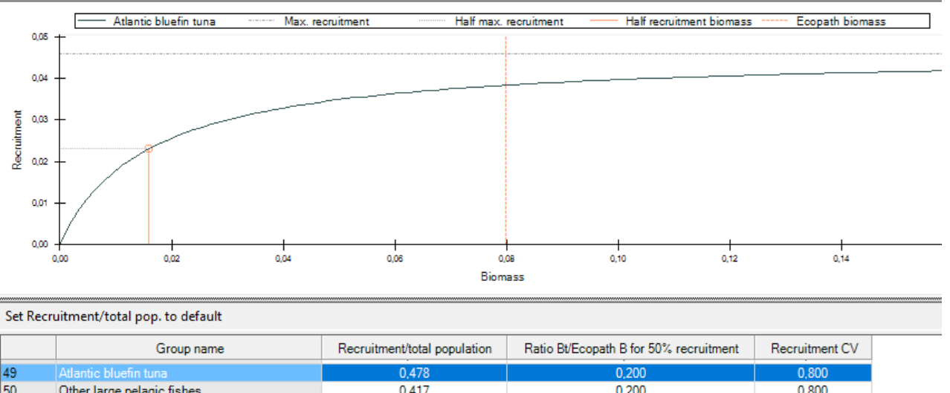
Figure 3. Recruitment, as shown in Ecopath
An example of the recruitment.csv file is shown below. The species_code and life_stage columns are used to identify the species and life stage for which the parameters are defined.
species_code | life_stage | RstockRatio | RHalfB0Ratio | cvRec
BOG |  | 0.893 | 0.2 | 0.8
HKE | ADULT | 0.7134952 | 0.200000003 | 0.800000012
HKE | JUVENILE | 0.7677637 | 0.200000003 | 0.800000012
PIL | ADULT | 0.760691 | 0.200000003 | 0.800000012
MUT | ADULT | 0.700308 | 0.200000003 | 0.800000012
BFT |  | 0.4779542 | 0.200000003 | 0.800000012

3.2 QuotaShare
The quota for a species can be shared among fleets, and this is configured in the quotashare.csv file. Each fleet (a combination of gear_code and country_code) has its own column, giving its quota share for each species and life stage (a combination of species_code and life_stage). When this file is loaded, it is validated that the sum of all fractions should be 1.
species_code | life_stage | ART|ESP | ART|FRA | RECT|ESP | LLS|ESP | OTB|ESP | OTB|FRA | PS|ESP | PS|FRA | TM|FRA
BOG |  | 0.893 | 0.000902 | 0.00191 | 0.102 | 0.002188 | 0 | 0 | 0 | 0
HKE | ADULT | 0.288042551 | 0.175846451 | 0.000185151 | 0.138019551 | 0.204072351 | 0.191925651 | 0.001908294 | 0 | 0
HKE | JUVENILE | 0 | 0 | 0 | 0 | 0.5593836 | 0.4406164 | 0 | 0 | 0
PIL | ADULT | 0.001531402 | 0.001792785 | 0 | 0.00042525 | 0.008162616 | 0 | 0.446605249 | 0.302094849 | 0.239387849
MUT | ADULT | 0.04309707 | 0.001818013 | 0 | 0.002574048 | 0.8295135 | 0.122493 | 0.0005043912 | 0 | 0
BFT |  | 0.06074393 | 0.2440297 | 0.02454434 | 0.08319749 | 0.009978897 | 0 | 0.005768434 | 0.5717372 | 0

3.3 Initial Quota
At the beginning of the simulation, an initial quota should be sent to EwE and POSEIDON. And because no Biomass and CatchDisposition messages have been sent yet, the initial quota can't be calculated, and should be configured. The quota is expressed in kilograms.
species_code | life_stage | TAC
BOG |  | 50000
HKE | ADULT | 200000
HKE | JUVENILE | 14000
PIL | ADULT | 60000
MUT | ADULT | 60000
BFT |  | 100000

4. Inputs

4.1 InitialiseSimulation
Buf specification
This message contains the contract of the simulation, with the list of Species and Fleets etc. that are part of the scenario. This is also the moment the configuration files are downloaded from the S3 bucket and validated.
- quotashare.csv
- recruitment.csv
- initial_quota.csv

If the configuration files contain a Species or a fleet that is not part of the contract, the simulation is canceled and a descriptive error message is logged.

4.2 CreateRegulations
Buf specification
At the start of the simulation, the CreateRegulations message is sent to the Fisheries Authority service. It contains the Harvest control rules with which the Total Allowable Catch is calculated at the beginning of the year.
With a harvest control rule, the Fisheries Authority can implement a feedback mechanism that adjusts TACs based on observed biomass levels. For example, if the biomass of a particular species falls below a predefined threshold, the harvest control rule may reduce the TAC for that species to prevent overfishing. Conversely, if biomass is above the threshold, the TAC may be increased to allow for sustainable harvesting.
The image below shows a harvest control rule as configured in Ecopath with Ecosim for the Atlantic Bluefin Tuna (BFT).
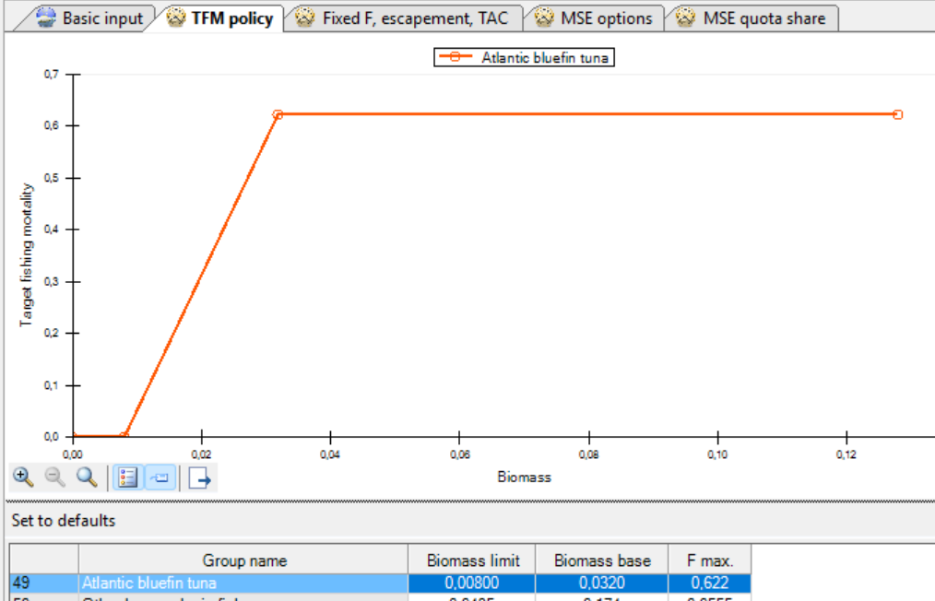
Figure 4. Harvest control rules, as shown in Ecopath
Only species with harvest control rules are included in the quota calculation. For the other species, there is no quota.
In the table at the bottom of the image you can see that each harvest control rule can be described by 3 numbers:
- Biomass limit (the lower limit of the biomass. When the biomass is below this, no fishing is allowed)
- Biomass base (the biomass threshold at and above which target fishing mortality is capped at F max)
- F max (the maximum target fishing mortality, expressed as the ratio of catch to biomass)

4.3 UpdateBiomass
Buf specification
Every month the Biomass of every applicable species is saved so it can be used in the calculation.

4.4 Update CatchDisposition (total)
Buf specification
The "gross catch" - "live discards" of all the cells is summed up, per species. This is aggregated every month, so when the new year starts the total amount of fish that has been harvested can be used in the calculation.

5. Outputs

5.1 GetRegulations
Buf specification
At the start of every regulatory year, the new quota for each applicable species is calculated and transmitted to the Ecopath (EwE) service and the POSEIDON service. This process is carried out within the GetRegulations message, issued by the SURIMI Controller.

5.1.1 Assessment
Upon receipt of this message, the Fisheries Authority performs a stock assessment (DoAssessment) using the latest biomass observations, the previous biomass estimate, and the catches accumulated over the preceding year. The assessment estimates the current state of each population. It is at this stage that stochastic (random) uncertainty is first introduced into the process, as the assessment incorporates a coefficient of variation to simulate observational error in the biomass estimate.
The Fisheries Authority applies stochastic variation only when the is_mse_run flag is true. When it is false, the Authority disables its random draws in assessment and quota calculation. Other models in the ensemble may still include stochastic processes.

5.1.2 Update Quotas and First year
When the simulation is in its first regulatory year, insufficient historical data exists to support a model-derived calculation. In this case, the Authority applies the pre-configured initial quotas defined in the scenario configuration. In all subsequent years, the Authority instead relies on the outcome of the assessment and delegates the quota calculation to the MSE (Management Strategy Evaluation) model via UpdateQuotas. It is within this step that a second source of random variation is applied (In an MSE run!), representing uncertainty in the quota-setting process itself, before the final Total Allowable Catch per species is determined.
Following the quota calculation, the accumulated catch totals for the year are cleared, allowing the next regulatory year to begin its accounting from zero.
Finally, the calculated quota for each species is apportioned across the applicable fishing fleets — each identified by gear type and country — in accordance with the quota shares defined in the scenario. The resulting set of Total Allowable Catches, specified per species and per fleet, is returned through the Controller, which subsequently distributes this information to:
- Ecopath, the ecology model responsible for simulating the response of fish populations and the broader ecosystem; and
- POSEIDON, the fleet model responsible for simulating how individual vessels and fleets adapt their fishing behaviour in response to the newly imposed limits.

In this manner, the quota determined for the coming year directly influences the subsequent behaviour of the simulated marine ecosystem.
Below is an illustrative output of GetRegulations for the first regulatory year, applying the quota shares in §3.2 to the initial TACs in §3.3. TAC values are expressed in kilograms.
Species Code | Life Stage | Gear Code | Country Code | TAC
BOG |  | ART | ESP | 44650
BOG |  | ART | FRA | 45.1
BOG |  | RECT | ESP | 95.5
BOG |  | LLS | ESP | 5100
BOG |  | OTB | ESP | 109.4
BOG |  | OTB | FRA | 0
BOG |  | PS | ESP | 0
BOG |  | PS | FRA | 0
BOG |  | TM | FRA | 0
HKE | ADULT | ART | ESP | 57608.5102
HKE | ADULT | ART | FRA | 35169.2902
HKE | ADULT | RECT | ESP | 37.0302
HKE | ADULT | LLS | ESP | 27603.9102
HKE | ADULT | OTB | ESP | 40814.4702
HKE | ADULT | OTB | FRA | 38385.1302
HKE | ADULT | PS | ESP | 381.6588
HKE | ADULT | PS | FRA | 0
HKE | ADULT | TM | FRA | 0
etc | etc | etc | etc | etc

5.1.3 Shared EwE calculation library
To ensure that the calculation of the TAC is done in the same way as is done in EwE, the same library is used.

Scientific Coordinator
Patrycja Antosz | paan@norceresearch.no

Project Management
Anne Dorthea Mæland | PMO-SURIMI@norceresearch.no

Press and Communications
Keegan Porter | keegan@erinn.eu
Emma Bello Gomez | emma@erinn.eu

More Information
Website | surimi-project.eu
LinkedIn | SURIMI Project
Bluesky | @surimi-project.bsky.social

